Lab Program -1 (Quadratic Equation)

WAP to find the roots of a quadratic equation. (Write Up)

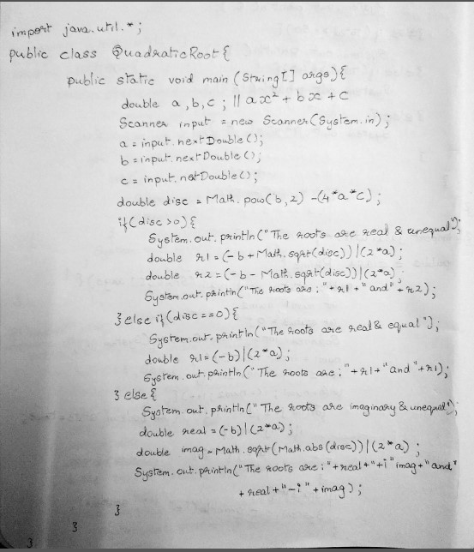

Code:

import java.util.Scanner;

public class SquareRoot {

    public static void main(String[] args) {

        double a,b,c;

        double dis;

        Scanner input = new Scanner(System.in);

        a = input.nextDouble();

        b = input.nextDouble();

        c = input.nextDouble();

        dis = Math.pow(b, 2)-(4\*a\*c);

        if(dis>0) {

            System.out.println("The roots are real and unequal");

            double r1 = (-b+Math.sqrt(dis))/(2\*a);

            double r2 = (-b-Math.sqrt(dis))/(2\*a);

            System.out.println("The roots are:"+r1+" and "+r2);

        }else if(dis == 0) {

            System.out.println("The roots are real and equal");

            double r1 = (-b)/(2\*a);

            System.out.println("The roots are:"+r1+" and "+r1);

        }else if(dis<0) {

            System.out.println("The roots are imaginary and unequal");

            double real,imag;

            real = (-b)/(2\*a);

            imag = Math.sqrt(Math.abs(dis))/(2\*a);

            //System.out.println(dis);

            System.out.println("The roots are:"+real+"+i"+imag+" and "+real+"-i"+imag);

        }

    }

}

Output for lab program -1

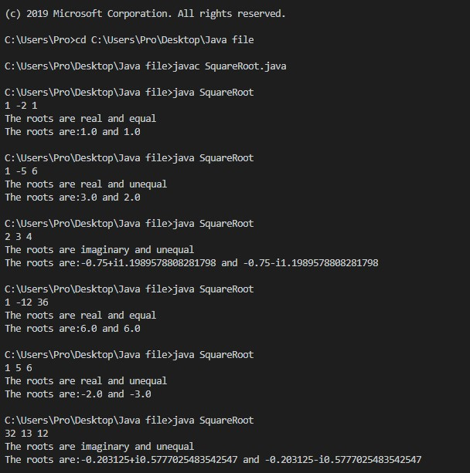

Lab Program-2

WAP to calculate the SGPA of a student.

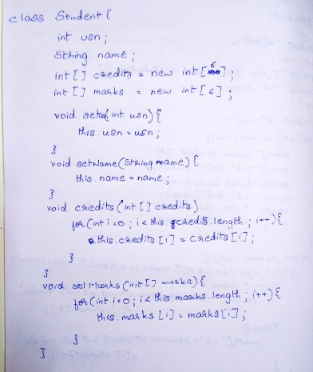

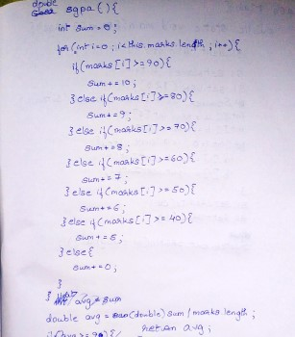

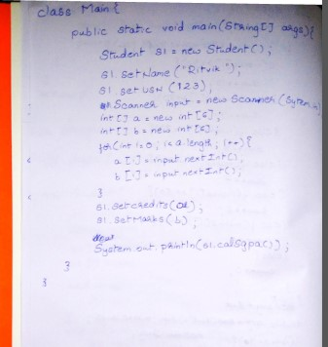

Code

import java.util.Scanner;

class Student{

    int usn;

    String name;

    int[] credits = new int[6];

    int[] marks = new int[6];

    void setUsn(int usn) {

        this.usn = usn;

    }

    void setName(String name) {

        this.name=name;

    }

    void setCredits(int[] credits) {

        for(int i=0;i<this.credits.length;i++) {

            this.credits[i] = credits[i];

        }

    }

    void setMarks(int[] Marks) {

        for(int i=0;i<this.marks.length;i++) {

            this.marks[i] = Marks[i];

        }

    }

    double calSGPA() {

        int sum=0;

        for(int i=0;i<marks.length;i++) {

            if(marks[i]>=90) {

                sum+=10;

            }else if(marks[i]>=80) {

                sum+=9;

            }else if(marks[i]>=70) {

                sum+=8;

            }else if(marks[i]>=60) {

                sum+=7;

            }else if(marks[i]>=50) {

                sum+=6;

            }else if(marks[i]>=40) {

                sum+=5;

            }else {

                sum+=4;

            }

        }

        return  (double)sum/marks.length;

    }

}

public class Usn {

    public static void main(String[] args) {

        Scanner input = new Scanner(System.in);

        Student s1 = new Student();

        System.out.println("Enter the name");

        s1.setName(input.nextLine());

        System.out.println("Enter the USN");

        s1.setUsn(input.nextInt());

        int a[]=new int[6];

        int b[]=new int[6];

        for(int i=0;i<a.length;i++) {

            System.out.println("Enter the credits and marks\n");

            a[i] = input.nextInt();

            b[i] = input.nextInt();

        }

        s1.setCredits(a);

        s1.setMarks(b);

        double result = s1.calSGPA();

        System.out.println(result);

        input.close();

    }

}

Output for lab program 2

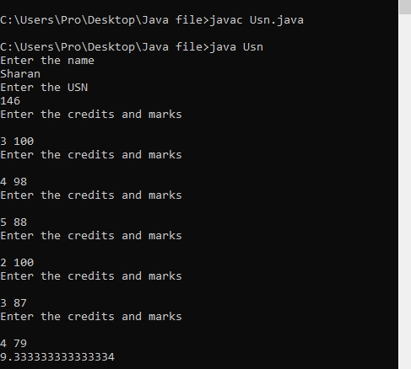

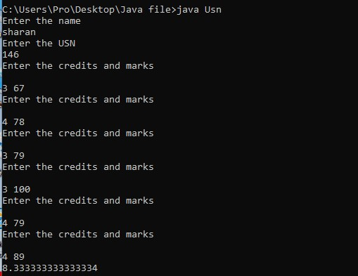

Lab Program-3

WAP to get the details of a book as given by user

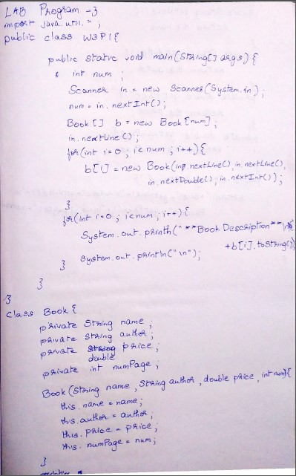

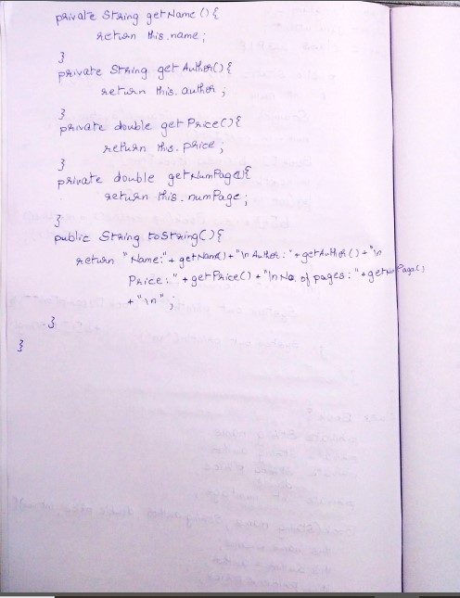

CODE:

import java.util.\*;

public class W3P1 {

    public static void main(String[] args) {

        int num;

        Scanner input=new Scanner(System.in);

        num=input.nextInt();

        Book[] b=new Book[num];

        for(int i=0;i<num;i++) {

            input.nextLine();

            b[i]=new Book(input.nextLine(),input.nextLine(),input.nextDouble(),input.nextInt());

        }

        for(int i=0;i<num;i++) {

            System.out.println("\n\*\*Book Description\*\*\n"+b[i].toString());

        }

    }

}

class Book{

    private String name;

    private String author;

    private double price;

    private int numPages;

    Book(String name,String author,double price,int num){

        this.name=name;

        this.author=author;

        this.price=price;

        this.numPages=num;

    }

    public String getName() {

        return name;

    }

    public String getAuthor() {

        return author;

    }

    public double getPrice() {

        return price;

    }

    public int getNumPages() {

        return numPages;

    }

    public String toString() {

        return "Name of the Book: "+getName()+"\nName of the author: "+getAuthor()+"\nPrice of the book: "+getPrice()+"\nNo. of pages: "+getNumPages()+"\n";

    }

}

Output:

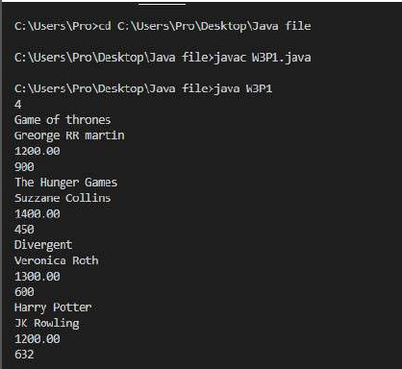

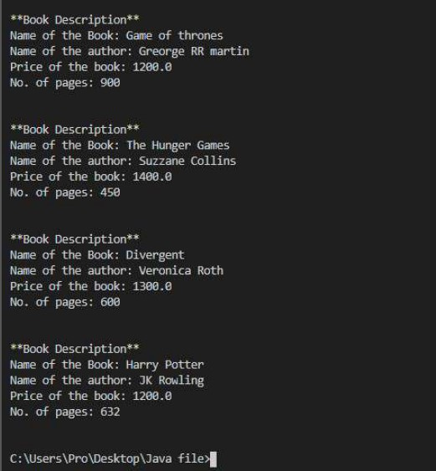

Lab Program-4

WAP to show function of abstract class and methods by extending triangle, rectangle and circle from an abstract class Shape.

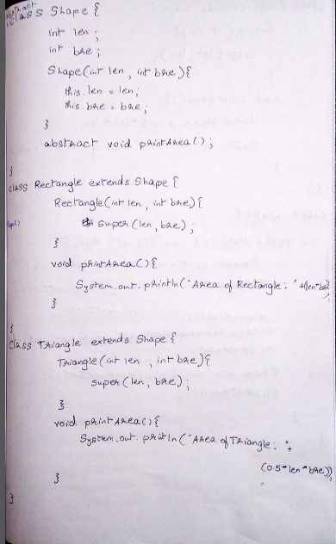

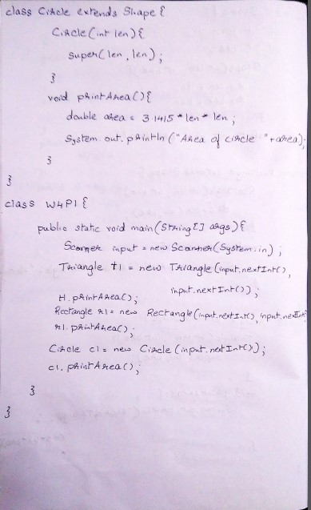

CODE

import java.util.\*;

abstract class Shape{

    int l,b;

    Shape(int len,int bre){

        l=len;

        b=bre;

    }

    abstract void printArea();

}

class Triangle extends Shape{

    Triangle(int base,int hei){

        super(base,hei);

    }

    void printArea() {

        double area = 0.5\*l\*b;

        System.out.println("Area of triangle = "+area);

    }

}

class Rectangle extends Shape{

    Rectangle(int len,int bre){

        super(len,bre);

    }

    void printArea() {

        double area = l\*b;

        System.out.println("Area of rectangle = "+area);

    }

}

class Circle extends Shape{

    Circle(int radius){

        super(radius,radius);

    }

    void printArea() {

        double area = 3.14\*(double)l\*(double)b;

        System.out.println("Area of circle = "+area);

    }

}

public class W4P1 {

    public static void main(String[] args) {

        Scanner input = new Scanner(System.in);

        Triangle t1 = new Triangle(input.nextInt(),input.nextInt());

        t1.printArea();

        Rectangle r1 = new Rectangle(input.nextInt(),input.nextInt());

        r1.printArea();

        Circle c1 = new Circle(input.nextInt());

        c1.printArea();

    }

}

OUTPUT:

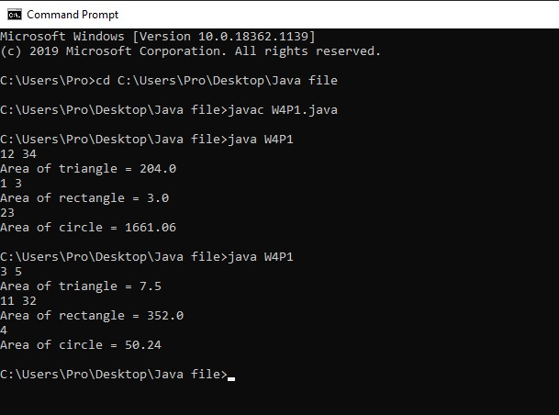

Lab Program-5:

WAP to create a banking system, with current and savings account.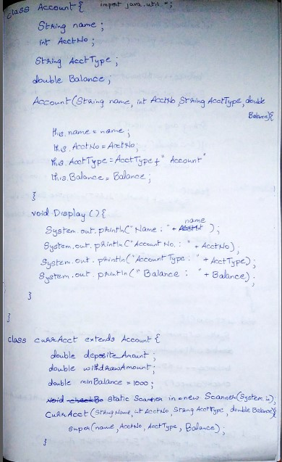

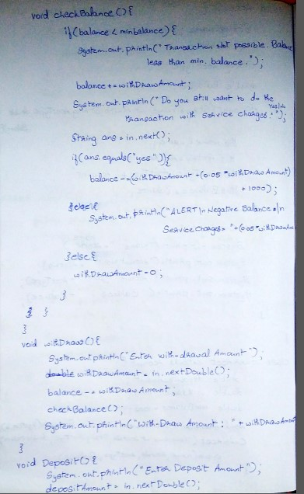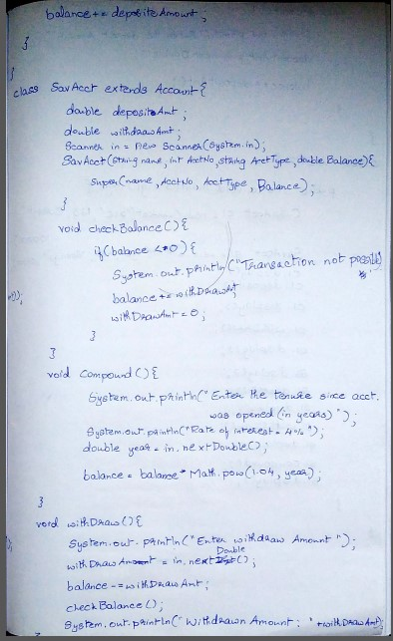



CODE:

import java.util.Scanner;

class Account{

    String name;

    int accountNo;

    String accountType;

    double balance;

    Account(String name,int accountNo,String accountType,double balance){

        this.name = name;

        this.accountNo = accountNo;

        this.accountType = accountType;

        this.balance = balance;

    }

    void DisplayStatus() {

        System.out.println("\*\*\*\*\*\*"+this.accountType+"\*\*\*\*\*\*\*");

        System.out.println("Name: "+this.name);

        System.out.println("Account no.:  "+this.accountNo);

        System.out.println("Account Type:  "+this.accountType);

        System.out.println("Balance: "+this.balance);

    }

}

class SavAcct extends Account{

    double depositAmount;

    double Withdrawmount;

    SavAcct(String name,int accountNo,String accountType,double balance){

        super(name,accountNo,accountType,balance);

    }

    static Scanner input = new Scanner(System.in);

    private void checkBalance() {

        if(balance<0) {

            System.out.println("Transaction is not possible. Balance becomes less than zero");

            balance+=Withdrawmount;

            Withdrawmount=0;

            Withdraw();

        }

    }

    void CalInterest() {

        System.out.println("Interest To Be added");

        System.out.println("Annual rate of interest: 4%");

        System.out.println("Enter the tenure in terms of year");

        int tenure = input.nextInt();

        balance = balance\*Math.pow(1.04, tenure);

    }

    void Deposit() {

        System.out.println("Enter the Deposit amount");

        depositAmount = input.nextDouble();

        balance+=depositAmount;

    }

    void Withdraw() {

        System.out.println("Enter the Withdrawal amount");

        Withdrawmount = input.nextDouble();

        balance-=Withdrawmount;

        checkBalance();

        System.out.println("Withdraw amount = "+Withdrawmount);

    }

}

class CurrAcct extends Account{

    double minBalance = 1000;

    double depositAmount;

    double Withdrawmount;

    static Scanner input = new Scanner(System.in);

    CurrAcct(String name,int accountNo,String accountType,double balance){

        super(name,accountNo,accountType,balance);

    }

    private void checkBalance() {

        if(balance<minBalance) {

            System.out.println("Transaction is not possible. Balance becomes less than minimum balance.");

            balance+=Withdrawmount;

            System.out.println("Do u still want to do the transaction with added service charges");

            String ans = input.next();

            if(ans.toLowerCase().equals("yes")) {

                balance-=(Withdrawmount+(0.05\*Withdrawmount)+1000);

                System.out.println("ALERT: Negative balance.\nService Charge added: "+(0.05\*Withdrawmount));

            }else {

                Withdrawmount = 0;

            }

        }

    }

    void Deposit() {

        System.out.println("Enter the Deposit amount");

        depositAmount = input.nextDouble();

        balance+=depositAmount;

    }

    void Withdraw() {

        System.out.println("Enter the Withdrawal amount");

        Withdrawmount = input.nextDouble();

        balance-=Withdrawmount;

        checkBalance();

        System.out.println("withdraw amount = "+Withdrawmount);

    }

}

public class Bank {

    public static void main(String[] args) {

        Scanner in = new Scanner(System.in);

        System.out.println("Enter the name");

        String name = in.next();

        System.out.println("Enter the account no.");

        int num = in.nextInt();

        int i=0;

        while(i<2) {

        System.out.println("Enter the account type\ncurr-current acc.\nsav-savings acct.");

        String type = in.next();

        if(type.equals("curr")) {

            double bal = in.nextInt();

            CurrAcct c1 = new CurrAcct(name,num,"Current Account",bal);

            c1.DisplayStatus();

            c1.Deposit();

            c1.DisplayStatus();

            c1.Withdraw();

            c1.DisplayStatus();

        }else if(type.toLowerCase().equals("sav")) {

            double bal = in.nextInt();

            SavAcct s1 = new SavAcct(name,num,"Savings Account",bal);

            s1.DisplayStatus();

            s1.Deposit();

            s1.DisplayStatus();

            s1.Withdraw();

            s1.DisplayStatus();

            s1.CalInterest();

            s1.DisplayStatus();

        }

        i++;

        }

        in.close();

    }

}

OUTPUT:

